Amazon Work Space
EC2 - Elastic Compute Cloud
Launch an instance
- Name and tags Naming the Instance Select windows OS

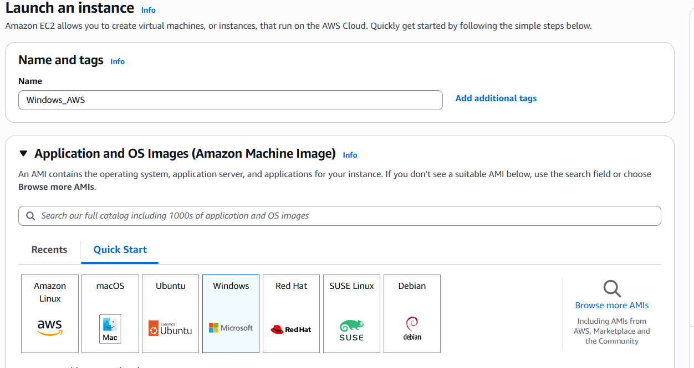

- Selecting instance type (t3.micro)

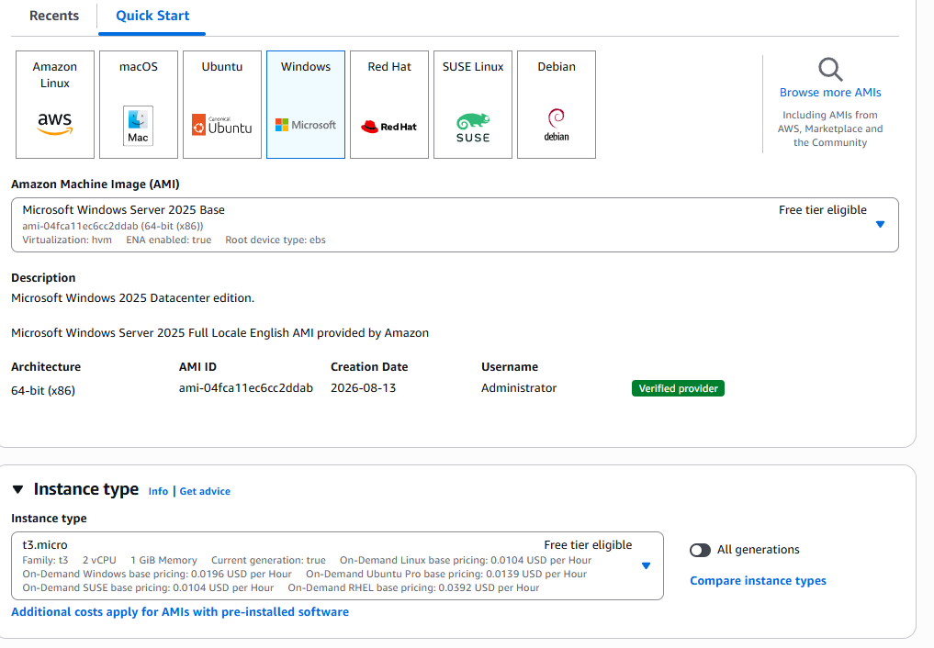
- Key pair (login) Create new key pair

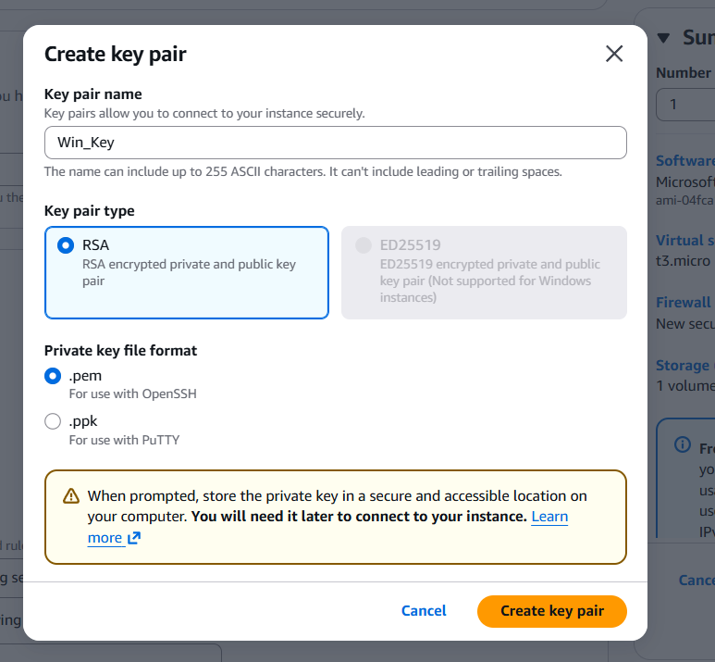

- Network settings Firewall (security groups) Launch an instance
To allow HTTP (port 80) and HTTPS (port 443) traffic in a network setting.

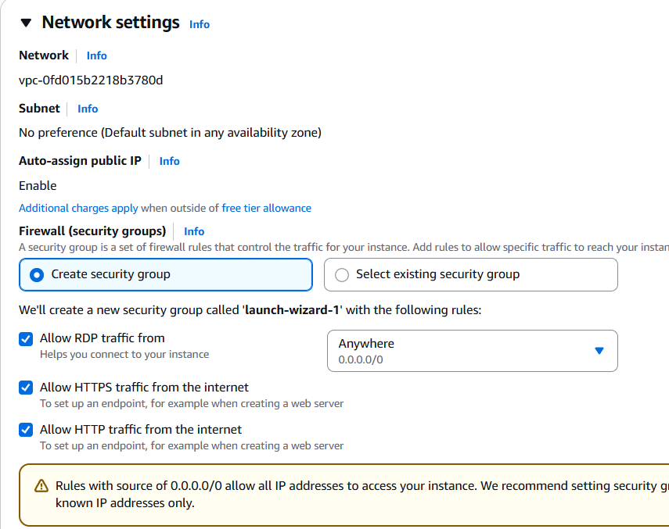
- 3/3 Check passed
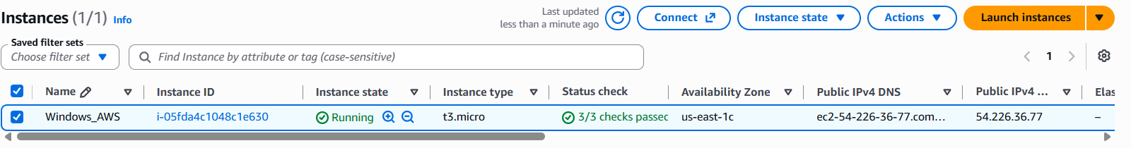

- Select the Instance Details Copy Public IP – for RDP

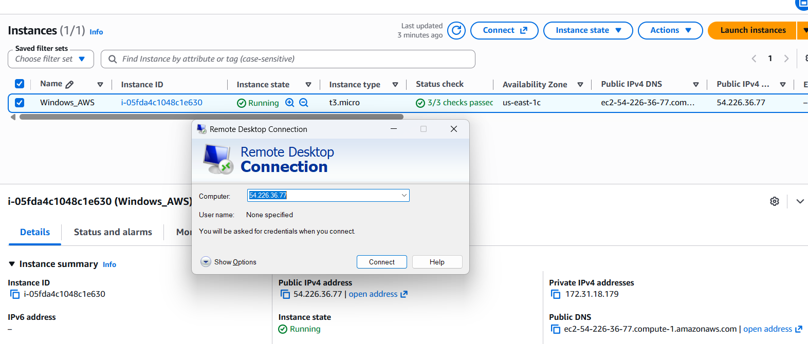

- Select the Instance Connect Instance Copy User name – Administrator
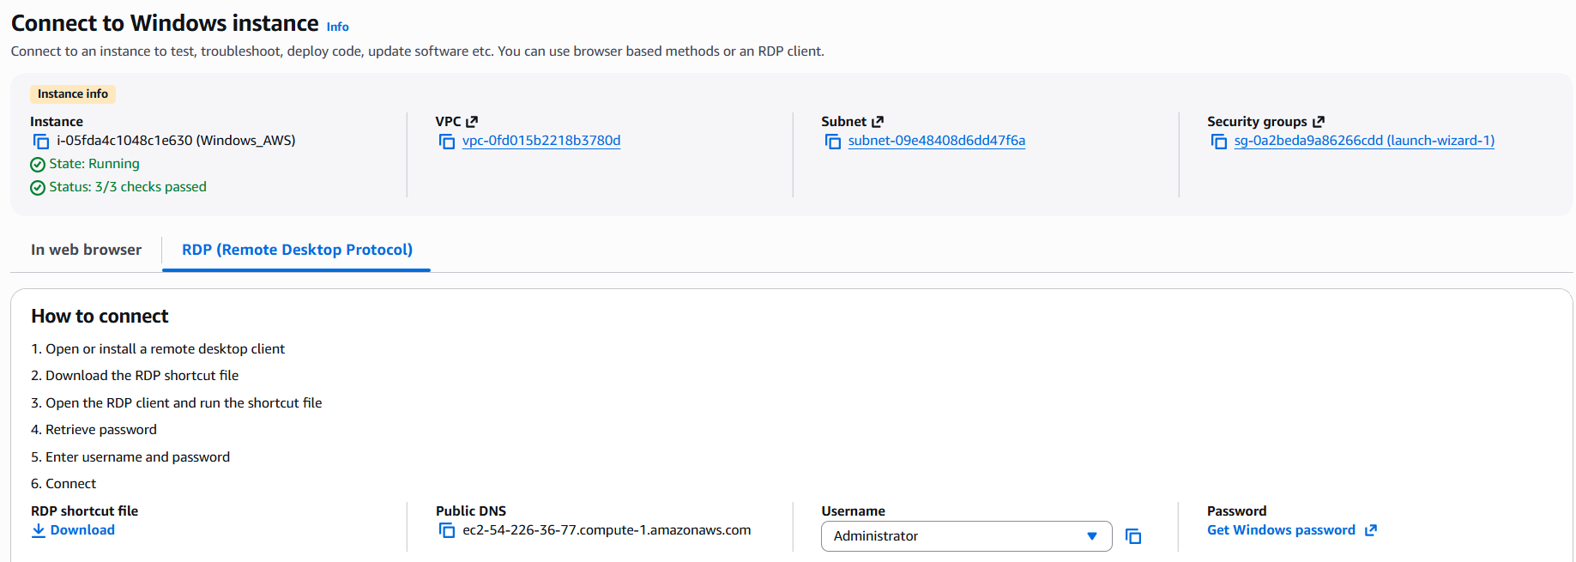

- Connect Instance Select Get Windows password –> Upload .pem file for Decrypt the password

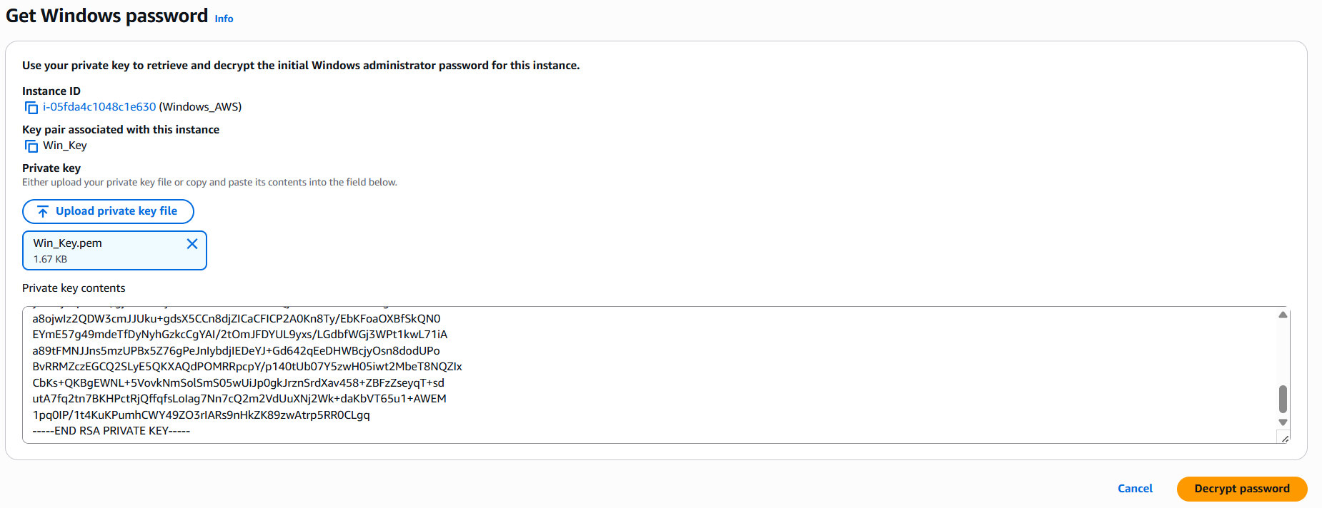

- Connect the Instance from RDP
